Prelab #3: Temperature Measurement with Thermistors

Purpose: The purpose of this lab is to calibrate a thermistor using the Steinhart-Hart model of thermistor performance, and then build a balanced bridge circuit with a differential amplifier to use the thermistor for temperature measurements.

Pre-Lab: Brief background – The Steinhart-Hart equation is the current accepted model for thermistor resistance vs. temperature behavior. The general equation is as follows:
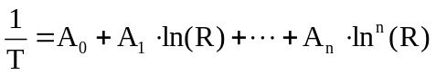
where T = temperature (in Kelvin), R = thermistor resistance, and A₀ – A_{n} = empirically derived constants. In practice, good correlation is achieved with a simplified third-order equation as follows:
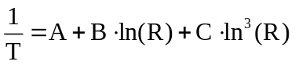
where A, B, C = empirically derived constants. At a minimum, a three-point calibration can be used to determine the constants A, B, and C for a particular temperature range of interest by solving three simultaneous equations.

To perform a three-point calibration of a thermistor over a given temperature range, the thermistor resistances at the temperature range extremes and midpoint are measured, and the constants for the thermistor can be determined from the following equations:

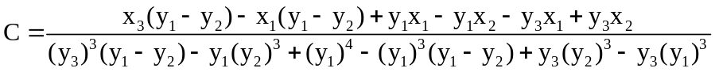

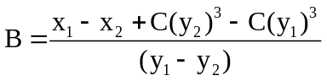

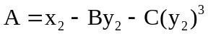

x₁ = 1/T_{low} y₁ = ln(R_{low})
x₂ = 1/T_{mid} y₂ = ln(R_{mid})
x₃ = 1/T_{high} y₃ = ln(R_{high})

T_{low} = low temperature calibration point (Kelvin)
T_{mid} = mid temperature calibration point (Kelvin)
T_{high} = high temperature calibration point (Kelvin)
R_{low} = low temperature resistance (ohms)
R_{mid} = mid temperature resistance (ohms)
R_{high} = high temperature resistance (ohms)

1) The following values are obtained for the calibration of the thermistor: R₀ = 32,650.5Ω at 0°C; R₂₅ = 10,000Ω at 25°C; R₅₀ = 3,603.1Ω at 50°C. Based on these three empirical recordings, find the constants A, B, and C. Use the following conversion formula between Kelvin and centigrade:

T_{Kelvin} = T_{Centigrade}+273

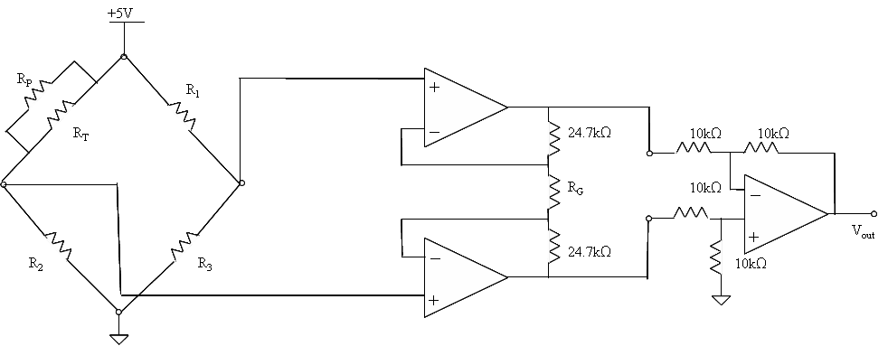
Assume that a thermistor is to be used in the following bridge circuit with an instrumentation amplifier for temperature measurements in the range of 0°C - 50°C. Note that a linearization resistor (R_{p}) has been added in parallel to the thermistor (R_{T}) as thermistors have non-linear behavior and this arrangement helps to linearize the response of the thermistor in the bridge circuit.
V₁
V₃
V₄
V₂

2) Choose the bridge resistor values for R₁, R₂, R₃, and R_{P} such that the bridge circuit is balanced at room temperature (i.e., at 25°C). Hint: Choose a value for R_{P} that is equal to the thermistor resistance at 25°C, and choose the other bridge circuit resistor values to give a balanced bridge (0V for the bridge output, V₁-V₂) at the center of the temperature range.

3) Choose the gain resistor R_{G} such that the output (V_{out}) is -12V at 0°C. Use the previous values you found for R₁, R₂, R₃, and R_{P} .

Hint: Referring to Figure 3.5 in your Medical Instrumentation textbook, find V₁, V₂ based on R₀ (i.e., R_{T} at 0°C). Note that based on Equation (3.5), for this circuit and the desired V_{out}:

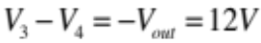

Then, find R_{G} based on Equation (3.7):

